User Manual: What's in My Fridge App (Fridge Meal Planner)
Version: 1.0 | Last Updated: December 2024 | Powered by: Zen coder
What is This App?
The Fridge Meal Planner is a smart web app that helps you create tasty, personalized recipes using ingredients already in your fridge. No need for online searches — just select what you have, and the app does the rest!


Quick Navigation
Getting Started Adding Ingredients Recipe Generation Features Overview
Troubleshooting Tips for Best Results
Getting Started

System Requirements
Web Browser: Chrome, Firefox, Safari, or Edge
Microphone: Required for voice input
Camera: Required for ingredient detection
Internet: Not required — works fully offline

How to Launch the App
1. Locate the index.html file
2. Double-click it OR
3. Open your browser manually
4. Navigate to the file location
5. App will open in your browser
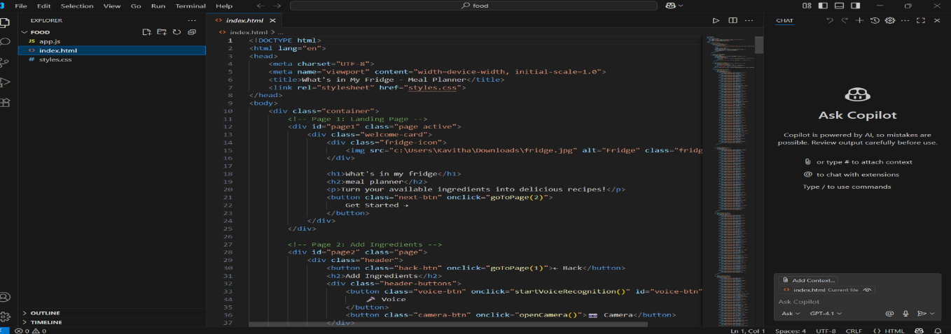

Adding Ingredients

Method 1: Manual Selection
Browse categories like Vegetables, Proteins, etc. Click to select ingredients (turns purple). Click again or hit “×” to remove. Visual Feedback: - Unselected: Light gray - Hover: Blue border - Selected: Purple with white text.
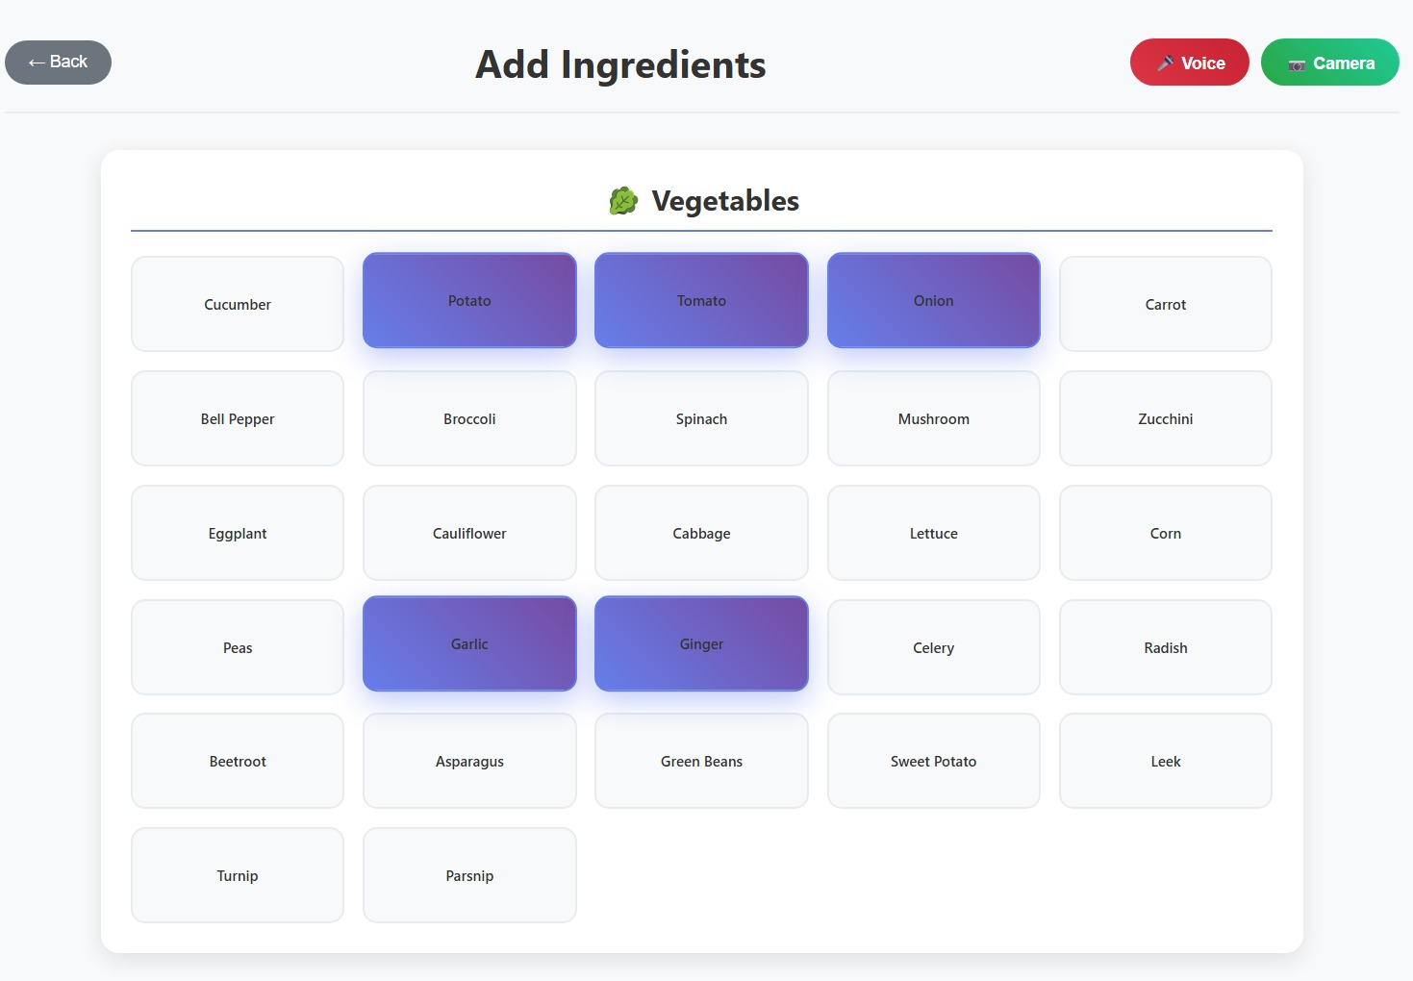

Method 2: Voice Recognition
Click button, speak ingredients (e.g., 'eggs, milk'), click stop when done. Features: - Real-time feedback - Audio confirmation - 50+ ingredients - No duplicates. 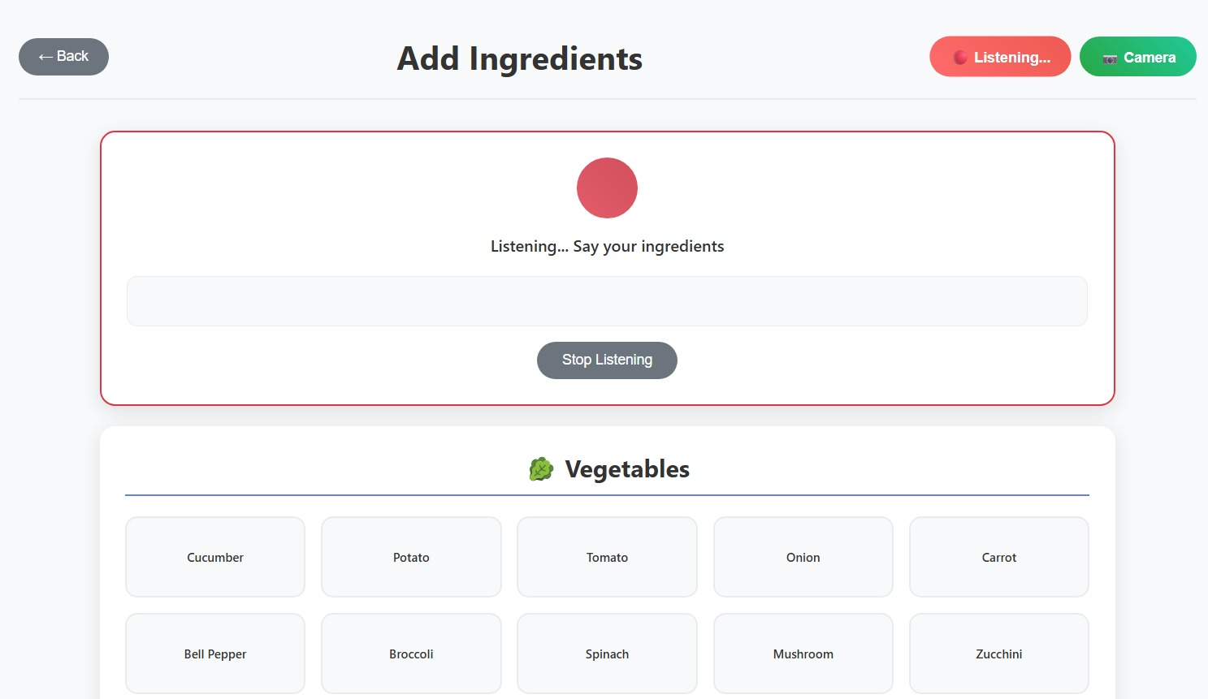

Method 3: Camera Detection
Click button, grant camera access, place ingredients well-lit, capture photo. Tips: - Natural light Plain background - Close-up - One at a time.
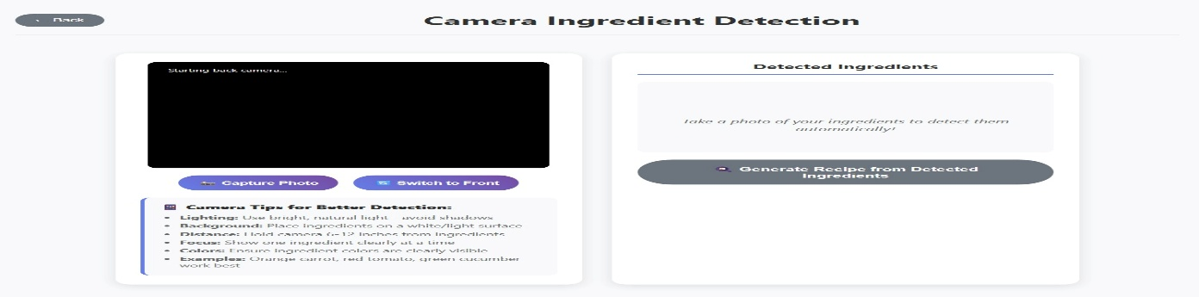
Recipe Generation

How It Works
1. Select at least 2 ingredients
2. Click 'Generate Recipe'
3. Wait 2 seconds
4. View your recipe
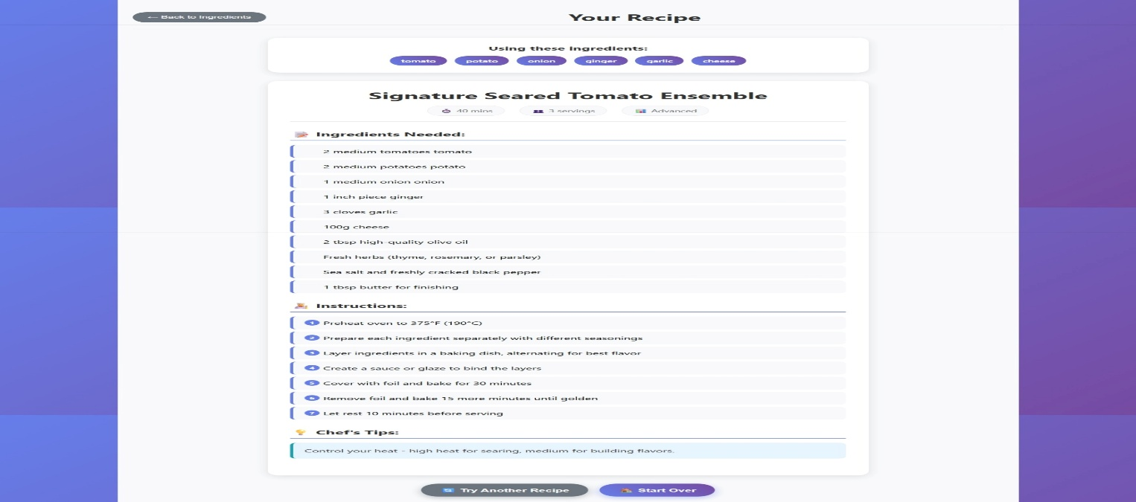
]|

Recipe Types
2 Ingredients: 5–10 mins 3–4 Ingredients: 15–25 mins 5+ Ingredients: 30+ mins
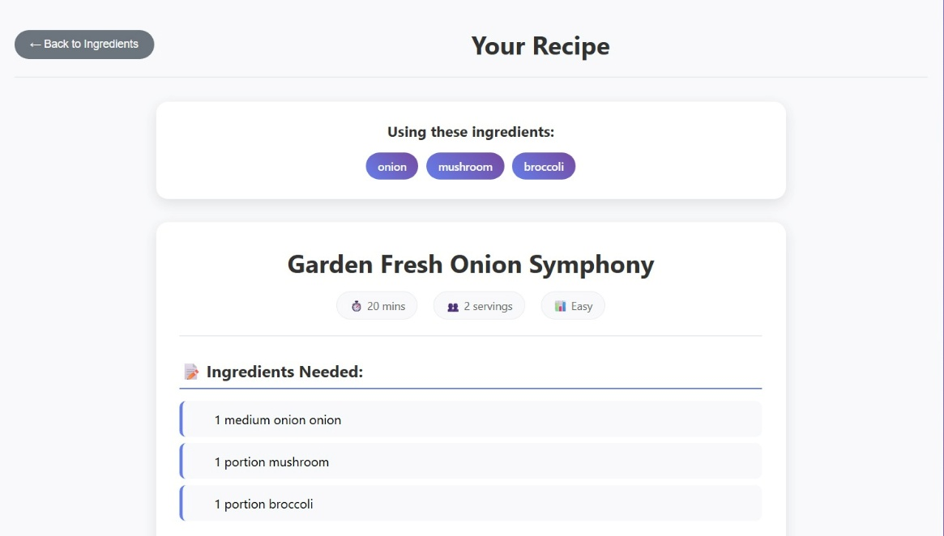
Recipe Details
Includes: Name, time, servings, difficulty, ingredients list, instructions, cooking tips
Features Overview
Smart Recipe Engine
100+ combinations, creative names, flexible inputs, cuisine fusion
Voice Recognition
50+ ingredients, natural language, real-time, audio feedback
Camera Intelligence
Colour-based, multi-detection, mapping, visual feedback
User Interface
Clean, responsive, animated, easy navigation
Troubleshooting
Voice Issues
Voice button not working? Use Chrome/Edge, allow mic, refresh page.
Camera Problems
Camera not starting? Allow access, check usage, refresh or switch browser.
Recipe Not Generated
Select 2+ ingredients, wait for result, try new combos, refresh if needed.
Tips for Best Results
Ingredient Tips
Start with 2–3 ingredients, mix categories, experiment!
Voice Tips
Speak clearly, use simple names, pause between items, quiet room
Camera Tips
Natural light, white background, close shots, clean items

Recipe Success Tips
Read full recipe, prep first, follow steps, taste and adjust
Enjoy Your Cooking!
Offline Friendly Endless Recipes Personal Chef Zero Waste Creative Ideas

